Make sure you know the equations, reagents and conditions for the following syntheses:

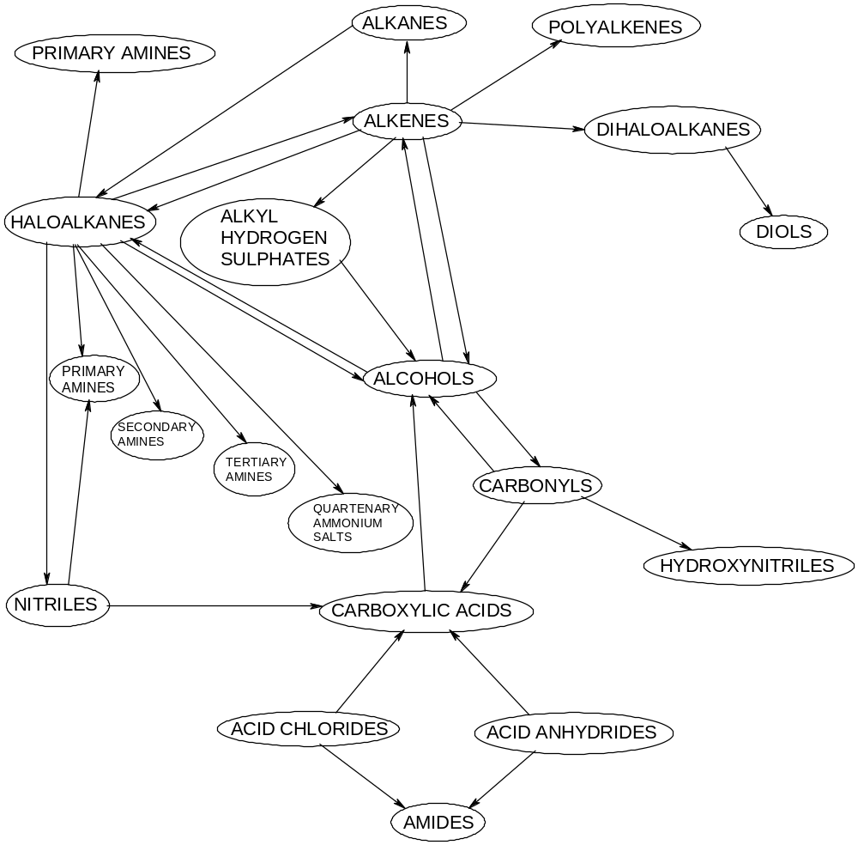

Make sure you know equations, reagents and conditions for the following condensation reactions:

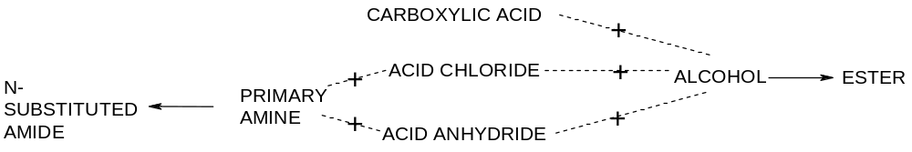

Make sure you know the equations, reagents and conditions for the following syntheses:

